Table. List of FT UNP students who take part in student exchange abroad through the SEA-TVET program organized by The Southeast Asian Ministers of Education Organization/SEAMEO (https://seatvet.seameo.org/)
Students’ Name | Study Program | Destination University | Year | Documentation
Pebri Romodhon | Meve | Donbos University Philipina | 2018 | 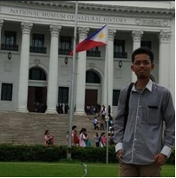
Dinda Khaira Latifa | Meve | ke Iloilo Science and Technology University Philipina | 2019 | 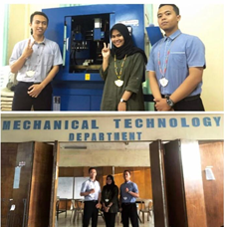

Table. List of foreign students in each FT-UNP study program

Recipient Study Program | Students’ Name | University | Year | Documentation
MEVE | Toma Fujimoto | National Maizuru College of Technology Jepang | 2017 | 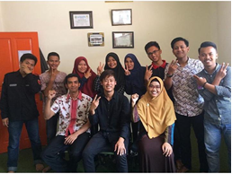
MEVE | Jb Hernandez | Nueva Ecija University of Science Technology (NEUST) Philipina | 2019 | 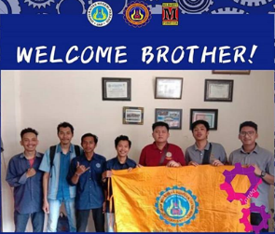
MEVE | Jerome Villacorta | Nueva Ecija University of Science Technology (NEUST) Philipina | 2019 | 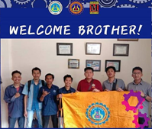
ATVE | Azizi Bin Abdullah | Malaysia | 2017
IE | Angelica Dian  Mariella Manzano | Don Mariano Marcos Memorial State University. La Union, Philippines | 2019 | 